AIP OMAN

**AERODROME CHART ˰˰˰˰ ICAO**

AD 2.OOMS-27 28 NOV 24

**AERODROME**

**CHART ˰˰˰˰ ICAO**

**WGS-84 AD ELEV 49 FT**

Muscat Tower North Muscat Tower South

118.825

118.4

Muscat Ground North Muscat Ground South

127.875

121.800

Muscat Information Muscat Clearance Delivery

126.800

125.575

58-18

MUSCAT/Muscat Intl

OMAN

58-19

23-37 23-37

APPROACH RADAR

SEA RESCUE STATION

ILS LOC 26R

20

WDI

23-36

23-36

H8

***2540***

*2024-10-31 12:23:21*

--------------------------------------------

Add H8

G6

46 47

PAPI

WDI 47

102

7143

97 95 93

X

88

182

***2882***

*2024-11-03 14:21:43*

--------------------------------------------

to be removed

183 187 18110

X

180 182

172 182 170 168

FUEL FARM

23-35

**AMENDMENT: EDITORIAL, TWY C5, C6 & C10 REMOVED, FENCE UPDATED.**

Prior to requesting a start up, push back and taxi clearance from Ground Control, all aircraft are instructed to contact the Clearance Delivery frequency on 125.575 MHz prior to start up and obtain an ATC clearance.

POLICE AIR WING HANGAR

X

POLICE AIR WING

747

HANGAR

23-35

58-15 58-16 58-17 58-18

***2882***

*2024-10-31 13:15:26*

--------------------------------------------

fence to be added

Annual rate of change 0.05°E

BEARINGS ARE MAGNETIC DIMENSIONS IN METRES

ELEVATIONS IN FEET

SCALE 1 : 20 000

|  |  |  |  |
| --- | --- | --- | --- |
| 100 | 0 | 100 200 300 | 400 500 M |
| 500 | 0 | 500 1000 | 1500 FT |

58-19

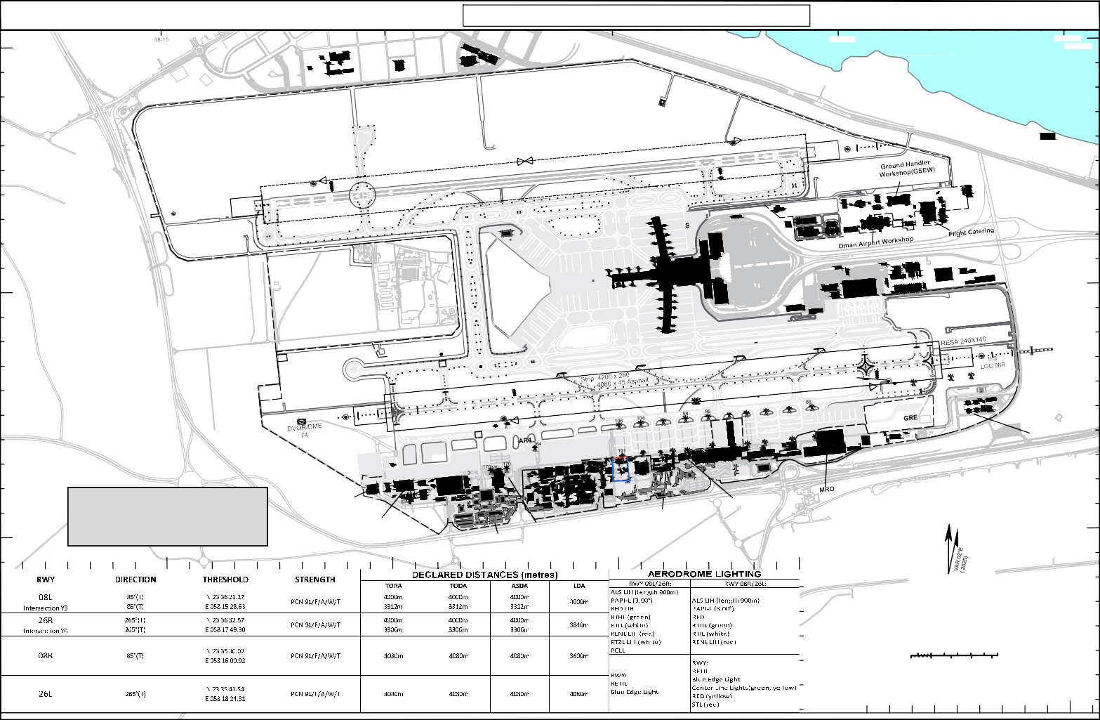

CIVIL AVIATION AUTHORITY AIRAC AIP AMDT 3-24